A.V. Eshwar

192211123

1. Configuration of Network Devices using Packet Tracer 192211123 tools (Hub, Switch, Ethernet, Broadcast)

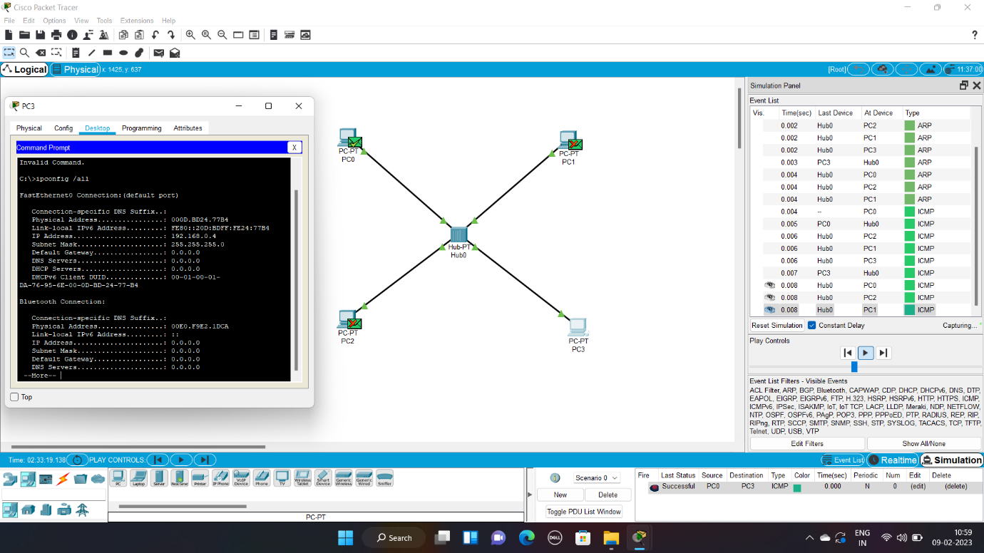

2. Design and Configuration of Star Topologies using Packet Tracer 192211123

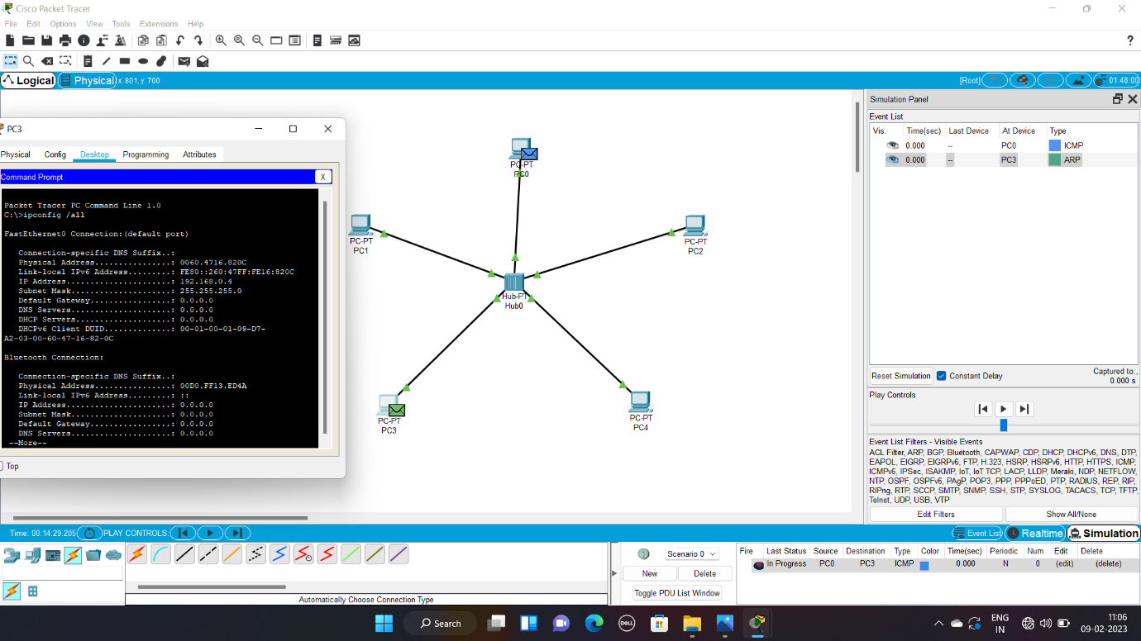

3. Design and Configuration of BUS Topologies using Packet Tracer 192211123

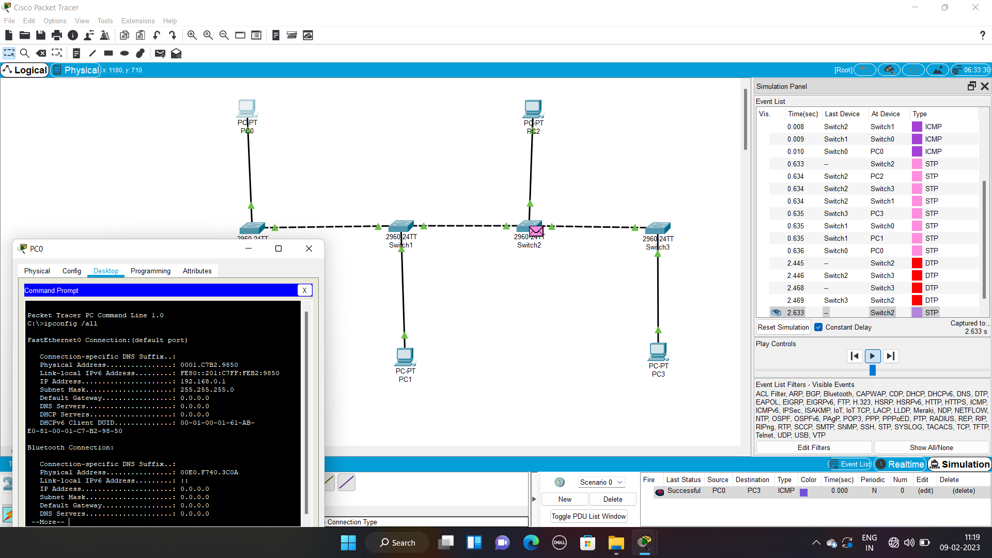

4. Design and Configuration of RING Topologies using Packet Tracer 192211123

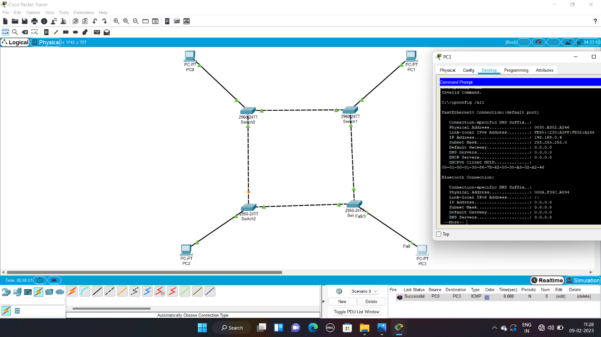

5. Design and Configuration of Mesh Topologies using Packet Tracer 192211123

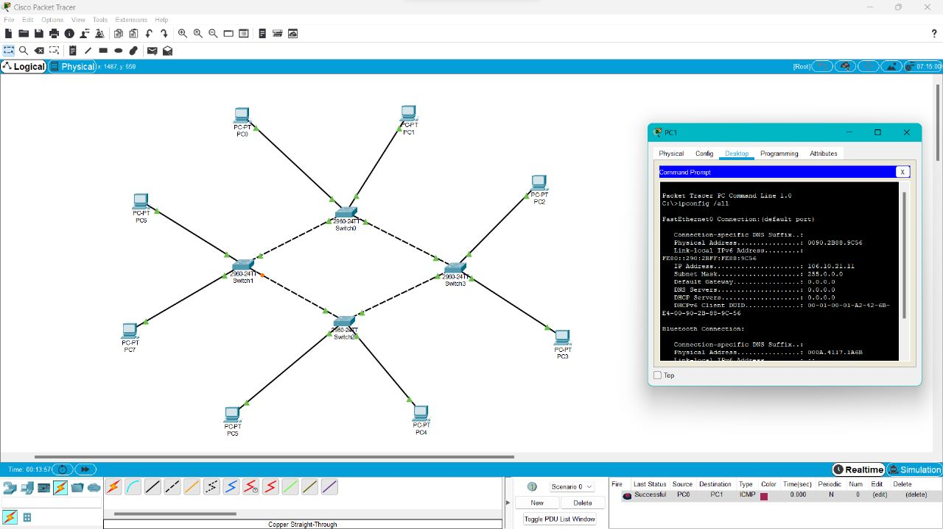

6. Design and Configuration of Tree Topologies using Packet Tracer 192211123

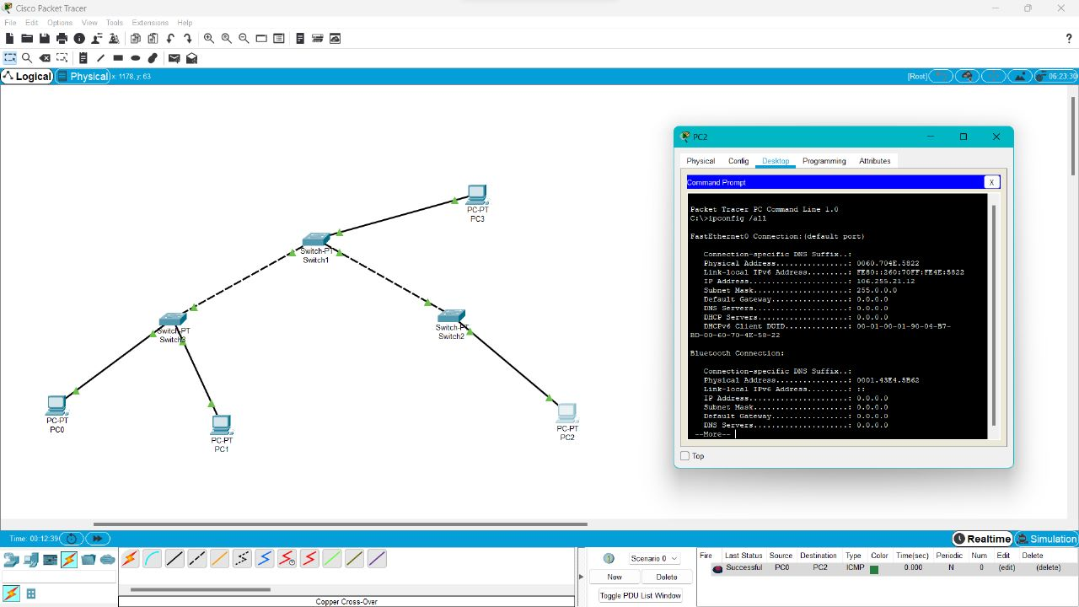

7. Design and Configuration of Hybrid Topologies using Packet Tracer 192211123

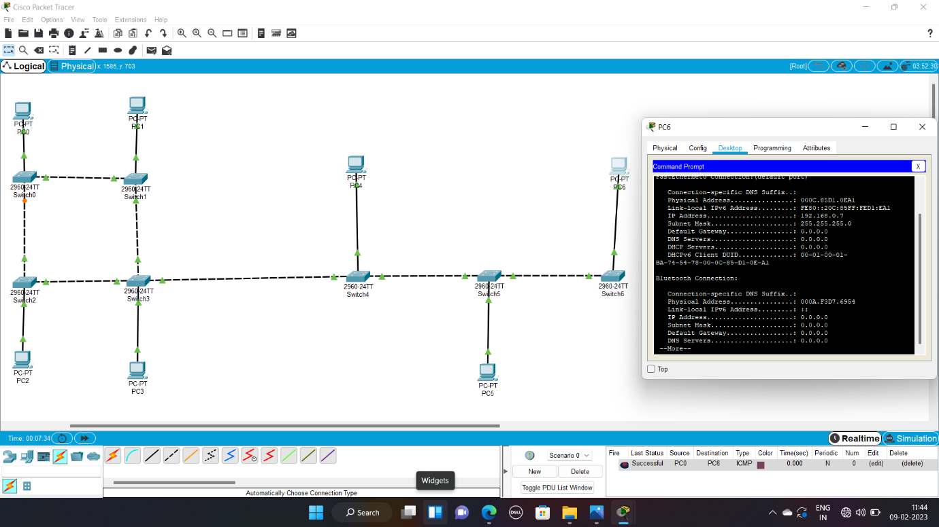

8. Data Link Layer Traffic Simulation using Packet Tracer 192211123 Analysis of ARP

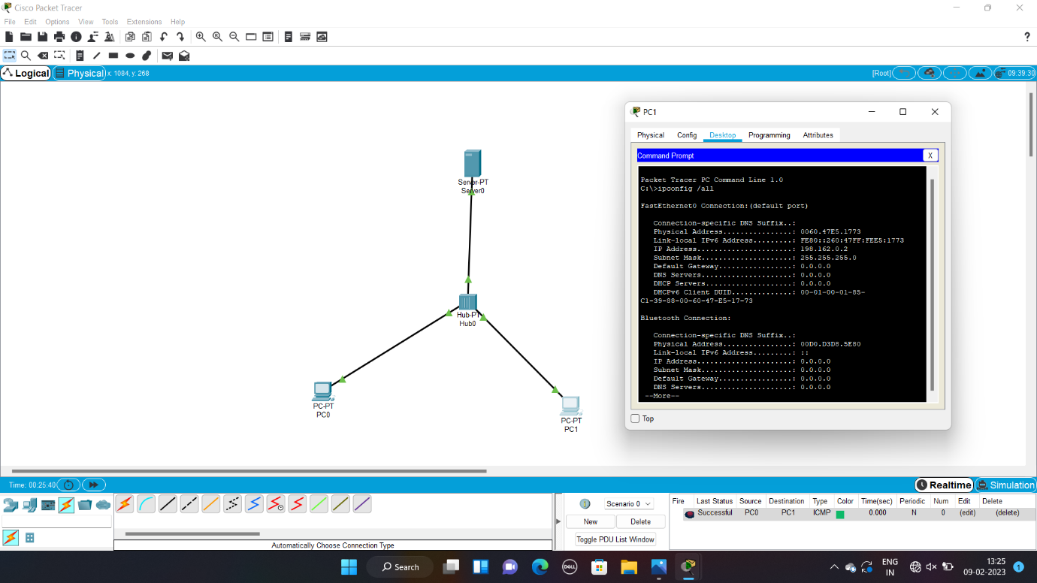

9. Data Link Layer Traffic Simulation using Packet Tracer 192211123 Analysis of LLDP

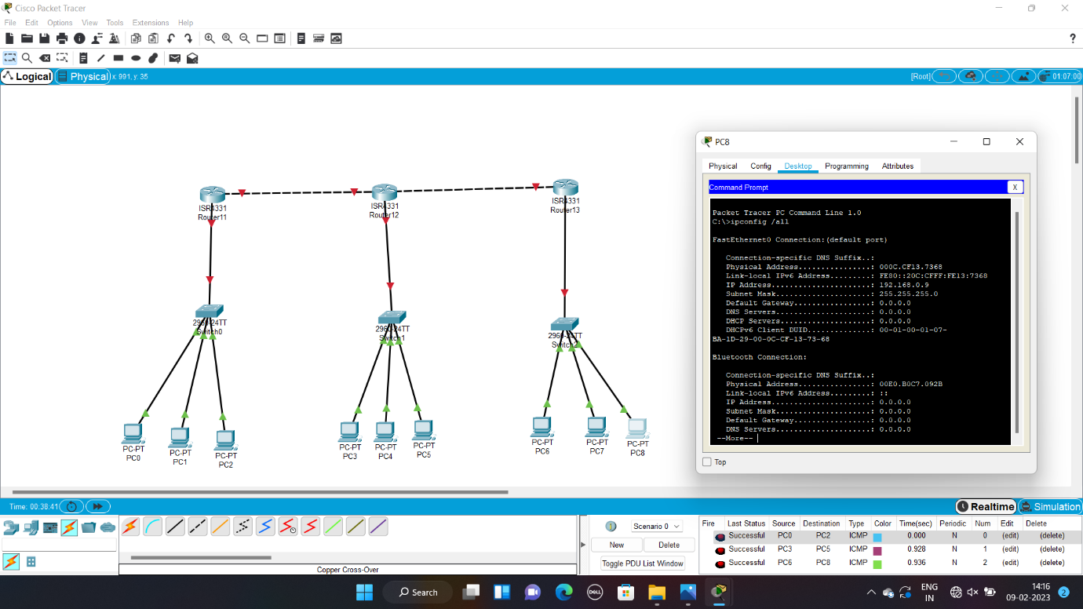

10. Data Link Layer Traffic Simulation using Packet Tracer 192211123 Analysis of CSMA/CD & CSMA/CA

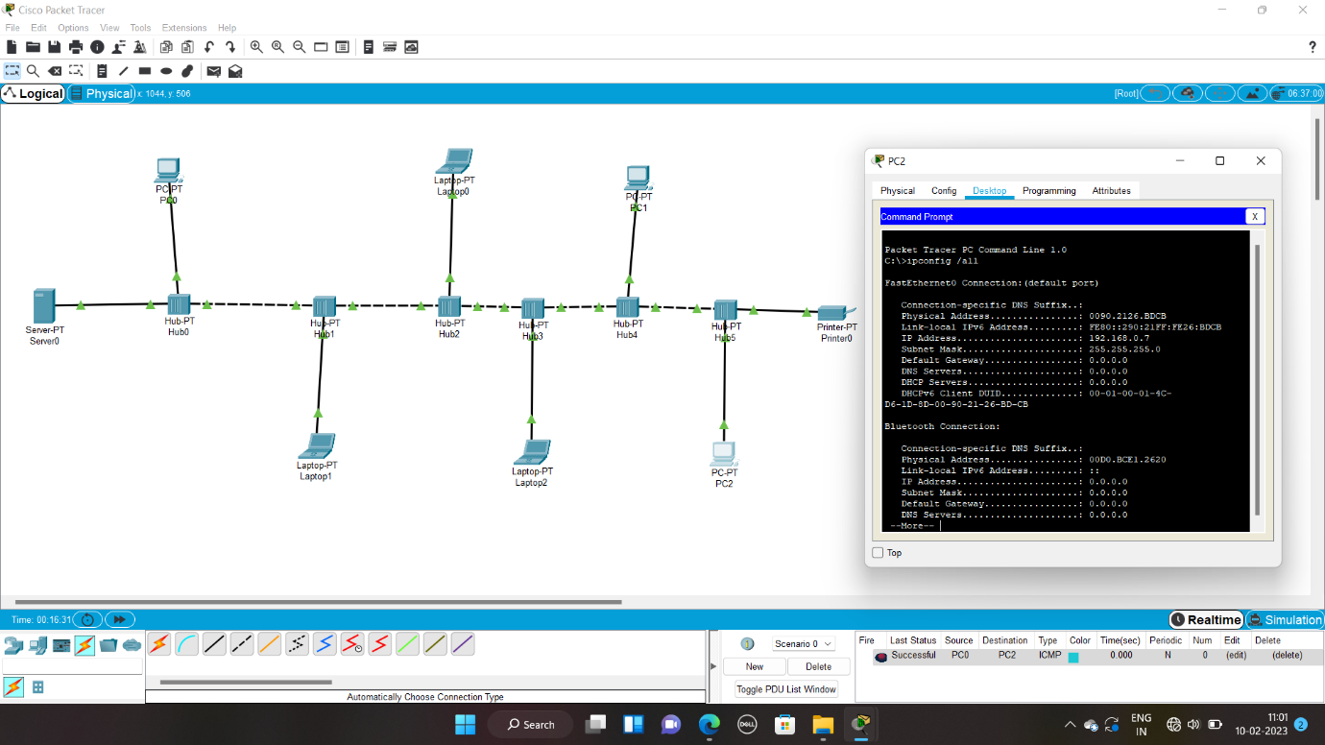

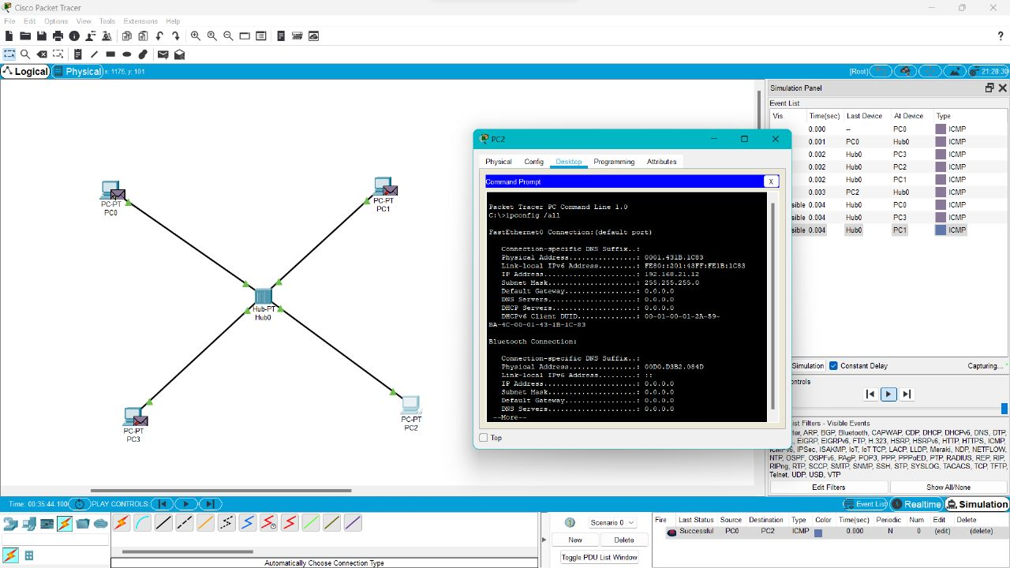

11. Implementation of Bit stuffing mechanism using C

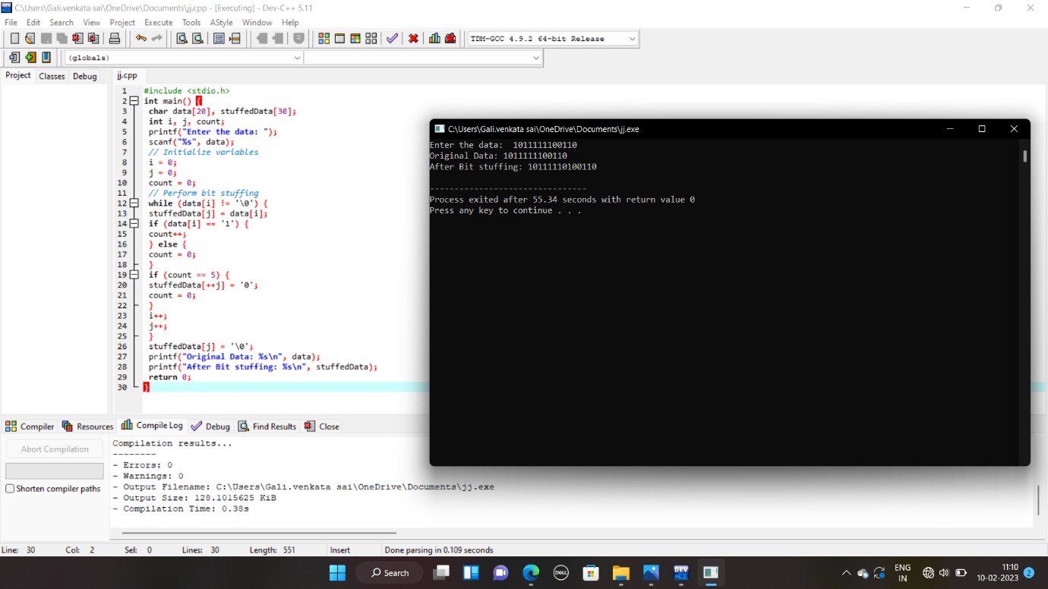

12. To design the two different networks with Static Routing techniques using Packet Tracer 192211123

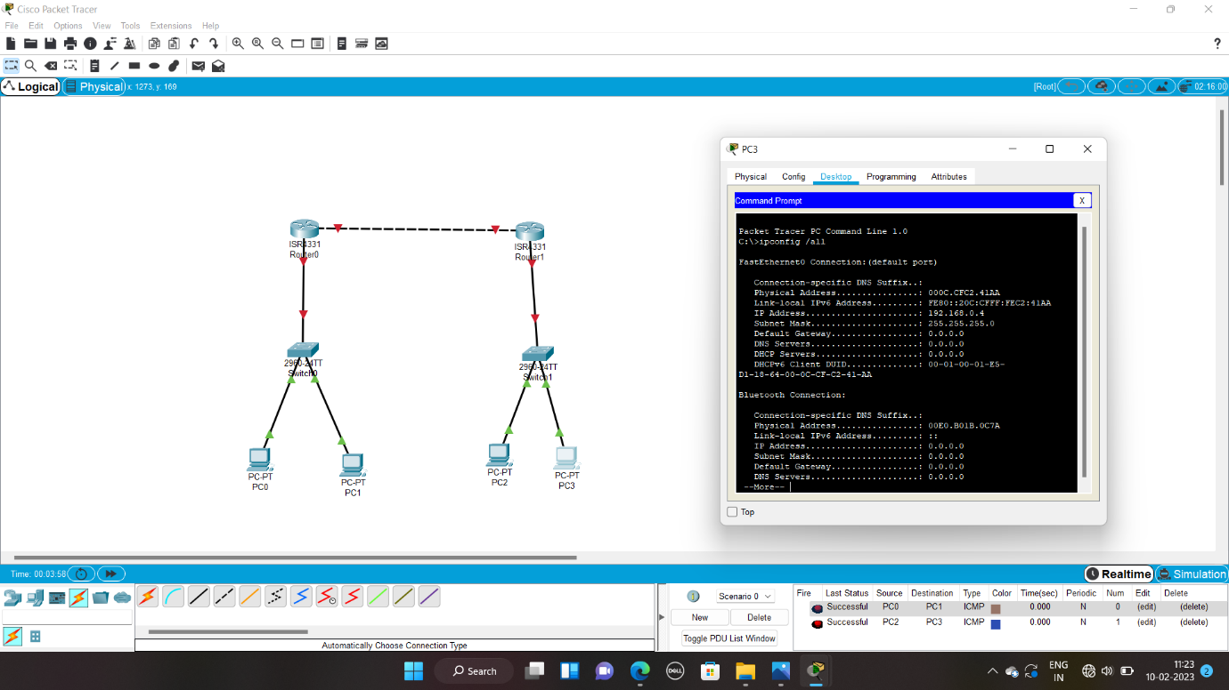

13. To design the Network with Dynamic Routing using Packet Tracer 192211123 (Distance vector & OSPF)

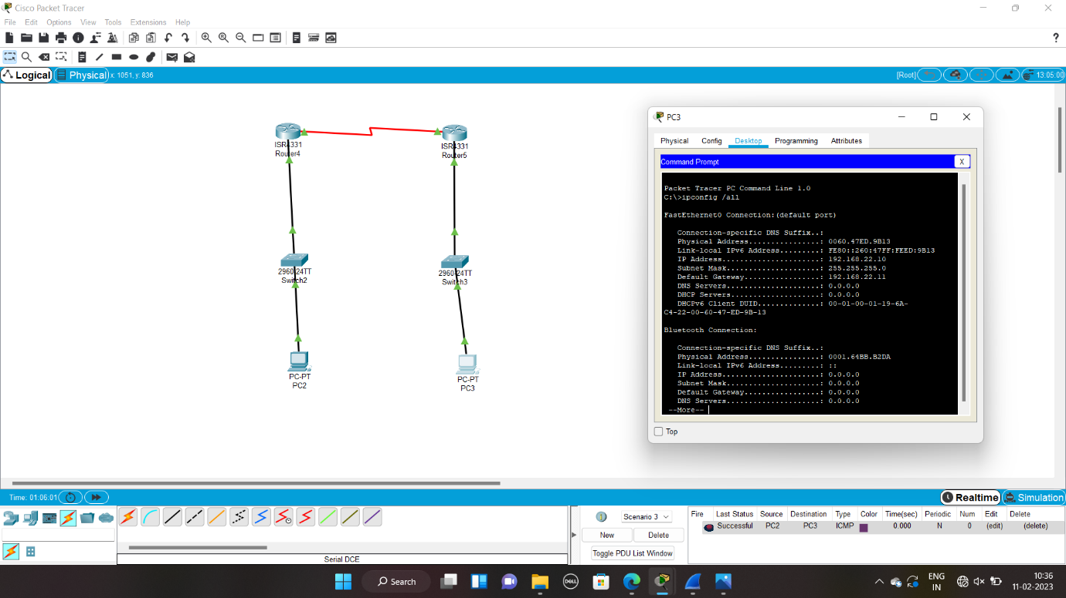

14. Design the Functionalities and Exploration of TCP using Packet Tracer 192211123

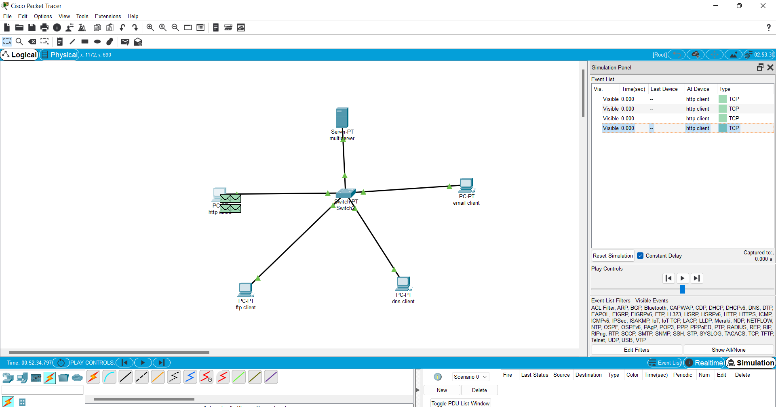

15. Design the Functionalities of Exploration UDP using Packet Tracer 192211123



16. Design the network model for Subnetting – Class C Addressing using packet tracer 192211123

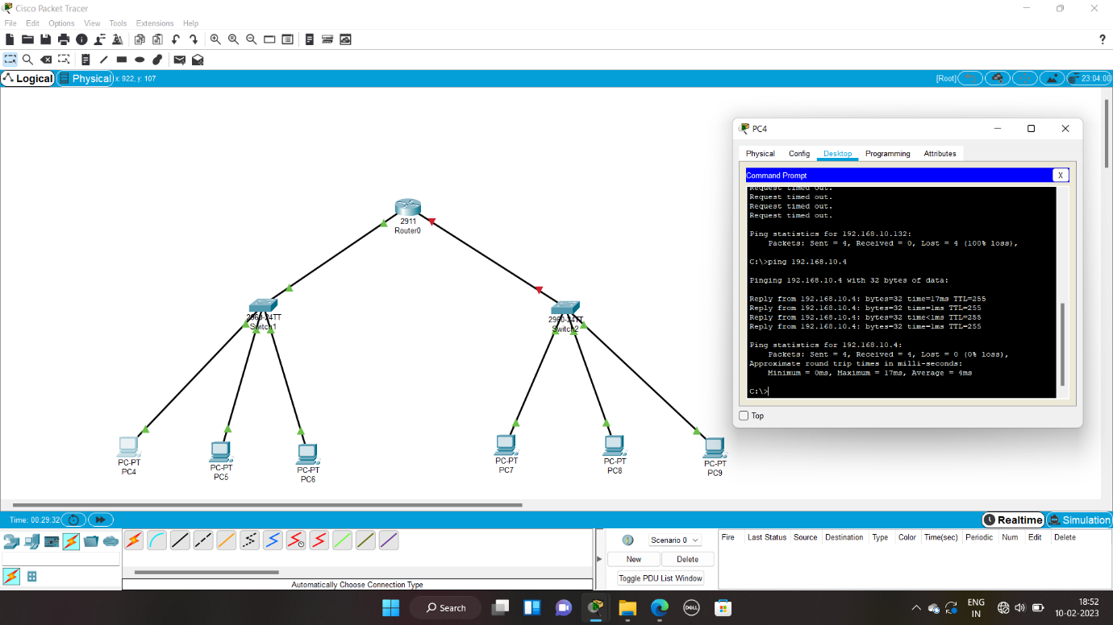

17. Implementation of server – client using TCP socket programming192211123



18. Implementation of server – client using UDP socket programming192211123



19. Simulating X, Y, Z Company Network Design and simulate using Packet Tracer 192211123

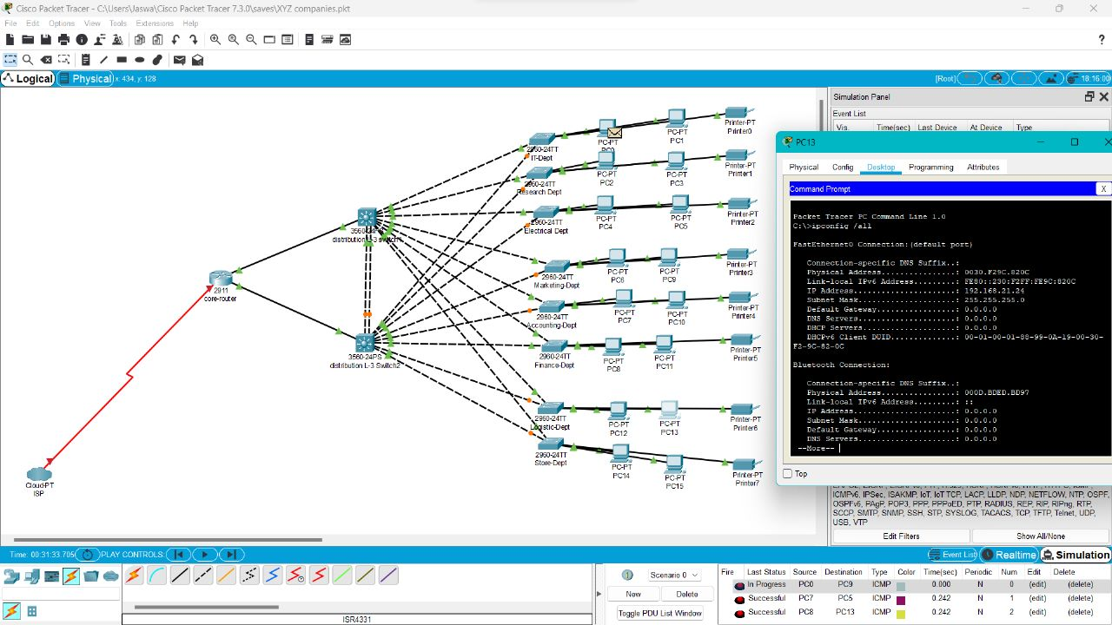

20. Configuration of DHCP (dynamic host configuration protocol) in packet tracer 192211123

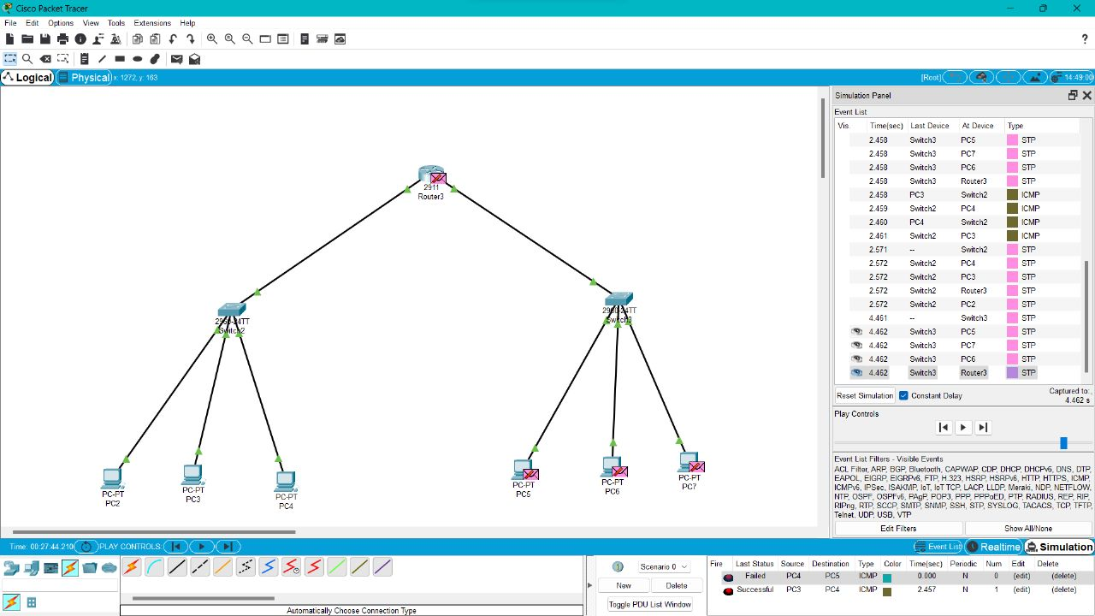

21.Make a Computer Lab to transfer a message from one node to another to design and simulate using Cisco Packet Tracer 192211123

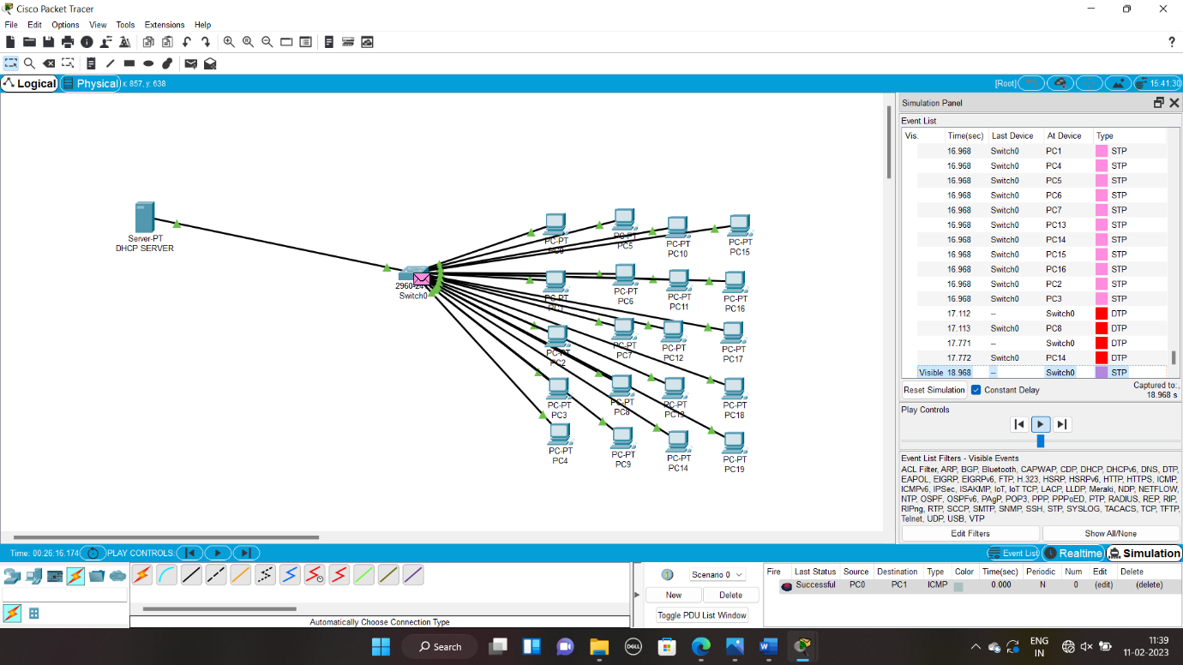

22. Transport layer protocol header analysis using Wireshark- TCP192211123

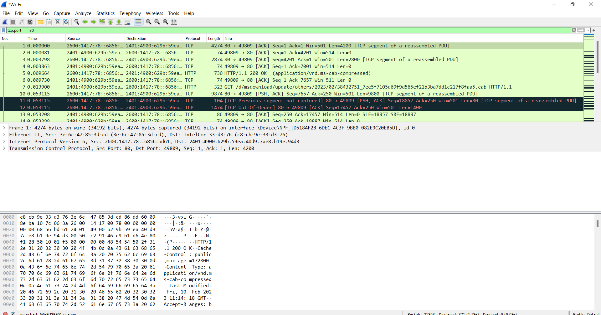

23. Network layer protocol header analysis using Wireshark – SMTP192211123

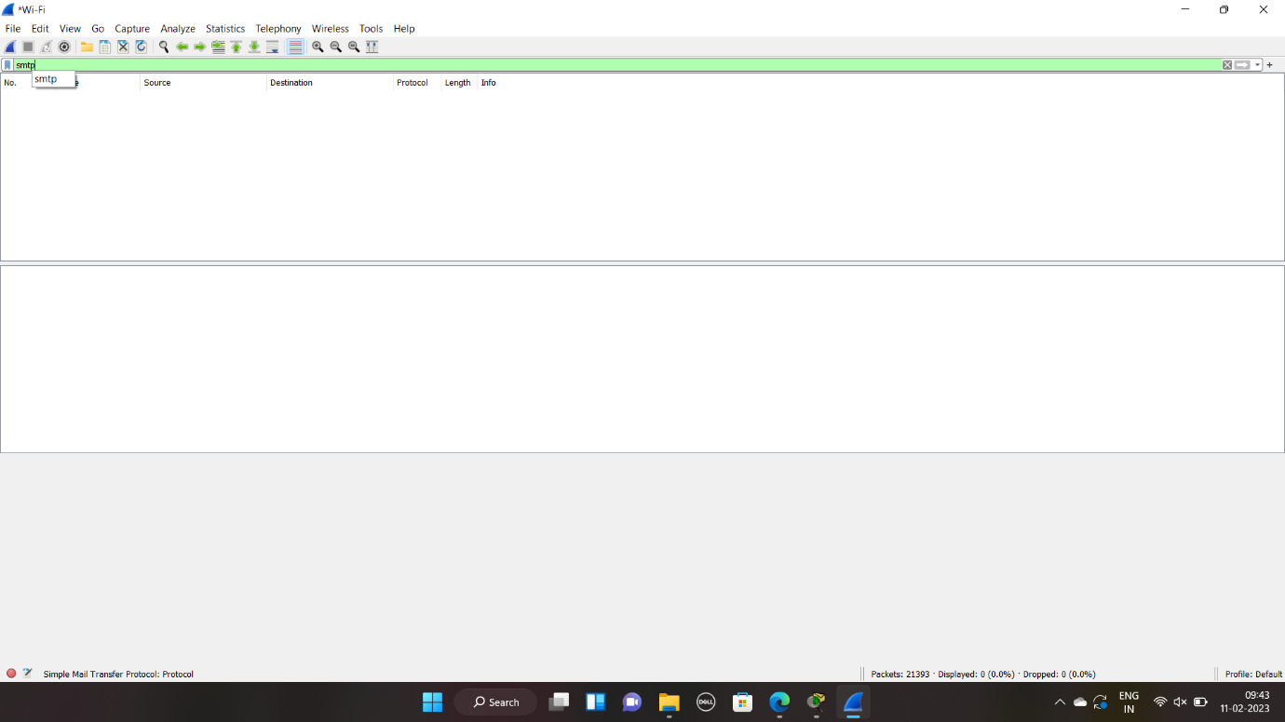

24. Network layer protocol header analysis using Wireshark – ICMP192211123

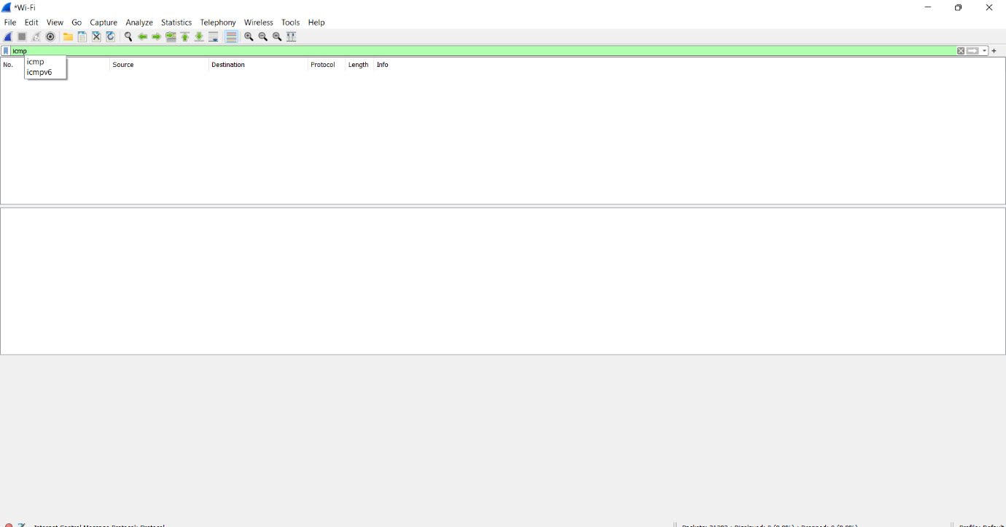

25. Transport layer protocol header analysis using Wireshark – UDP192211123

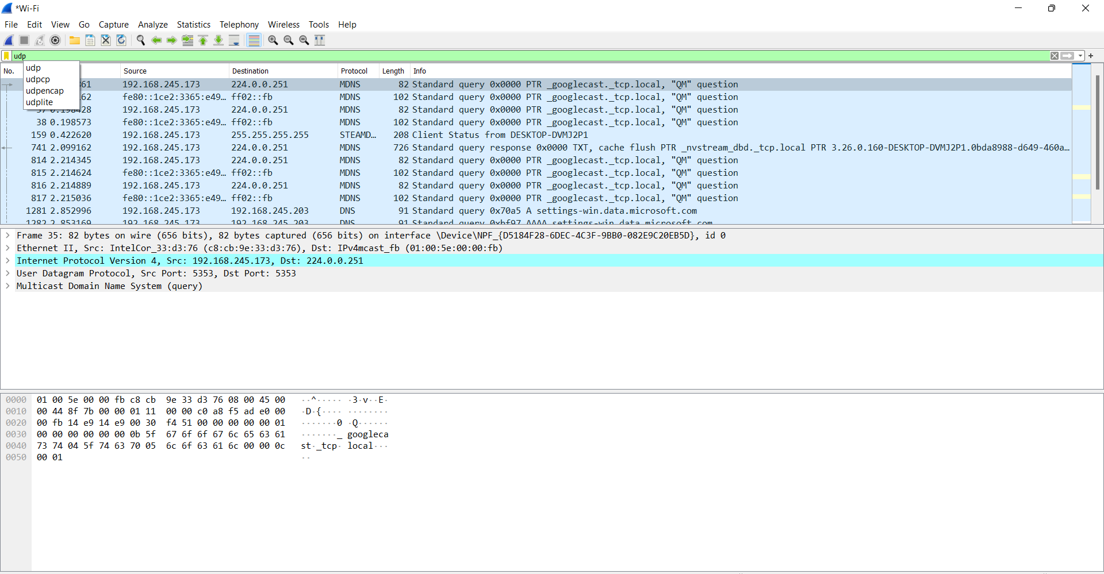

26. Network layer protocol header analysis using Wireshark – ARP192211123

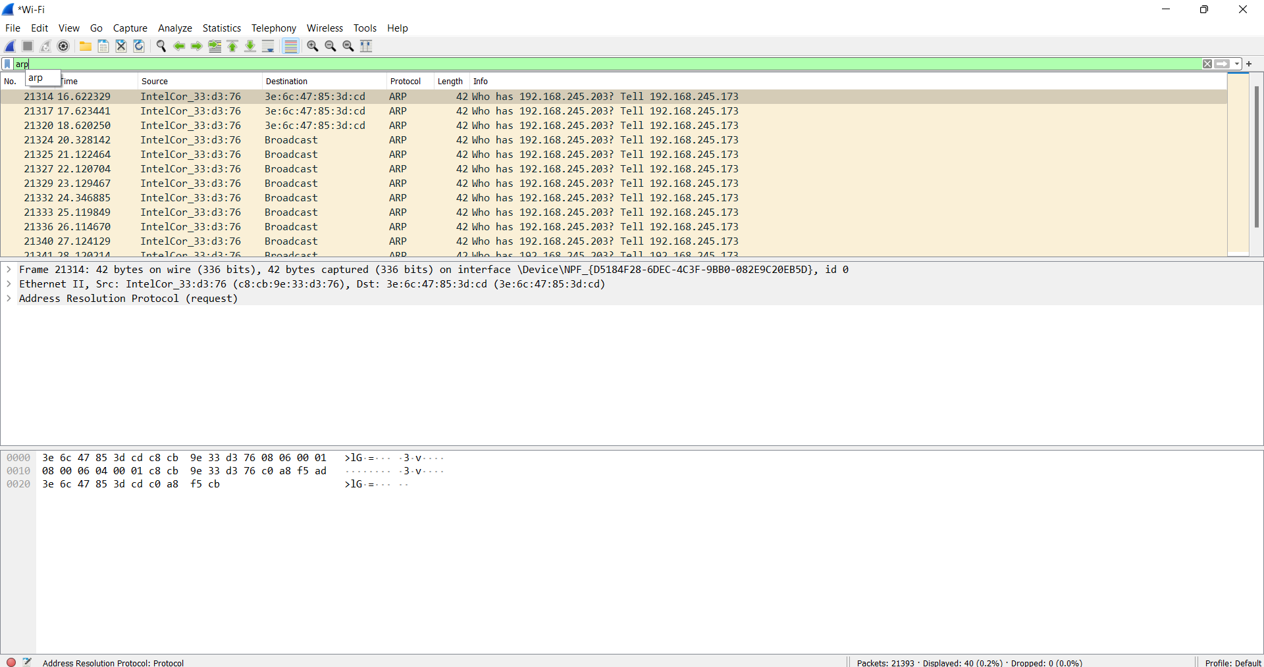

27. Network layer protocol header analysis using Wireshark – HTTP192211123

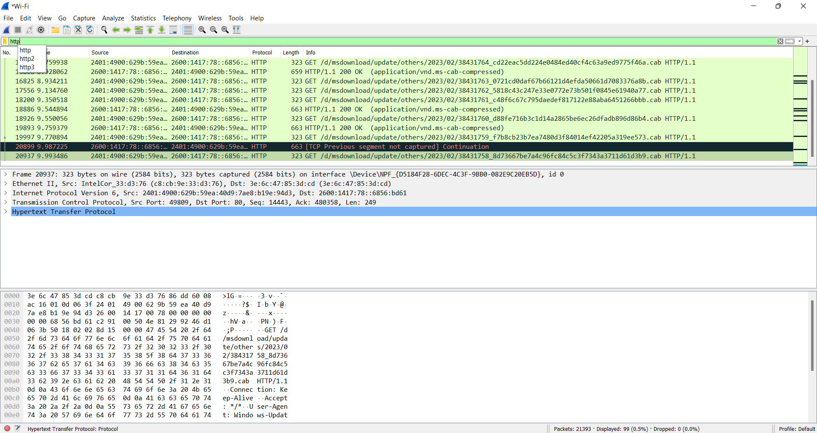

28. Demonstration of PING operation using ICMP in Wireshark192211123

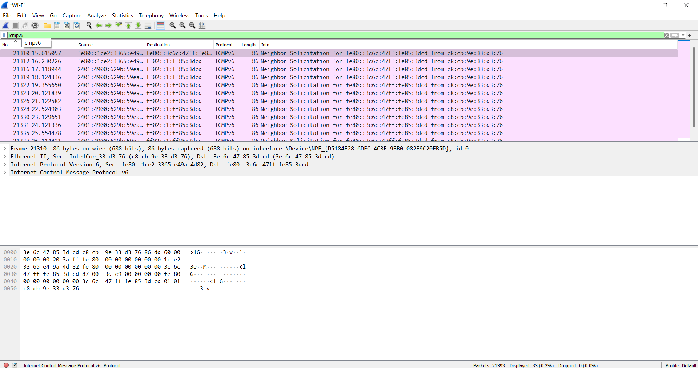

29. IOT Based Smart Home Using Cisco Packet Tracer 192211123

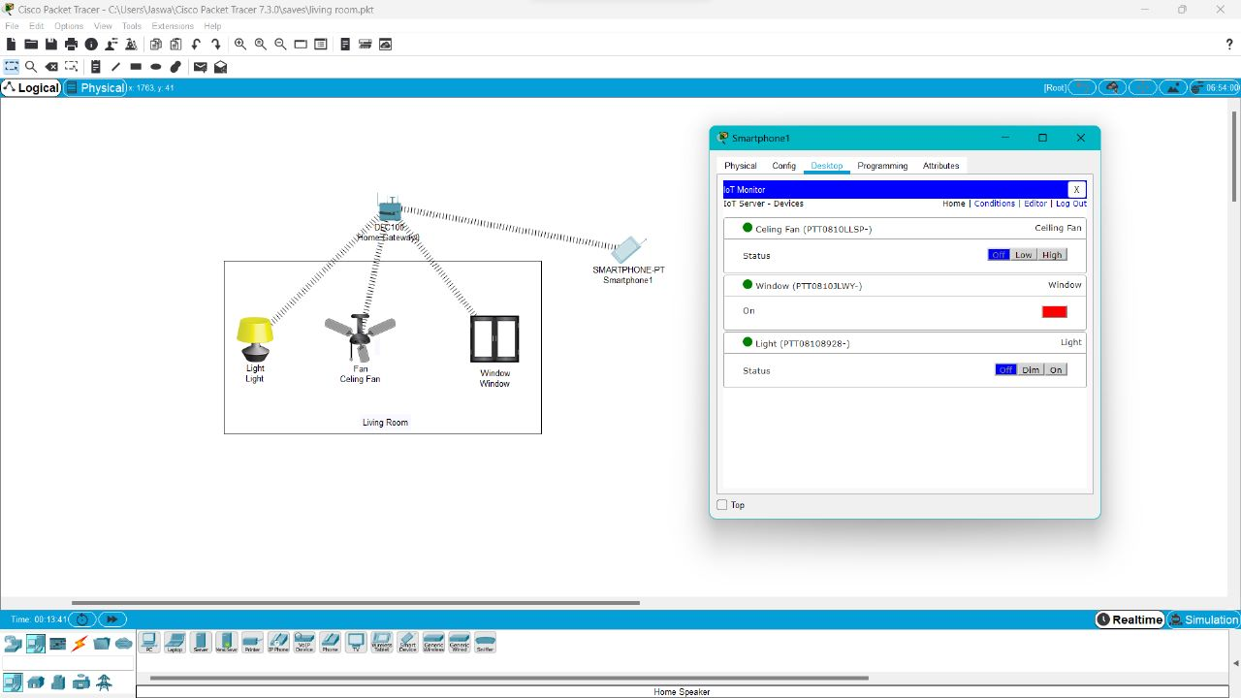

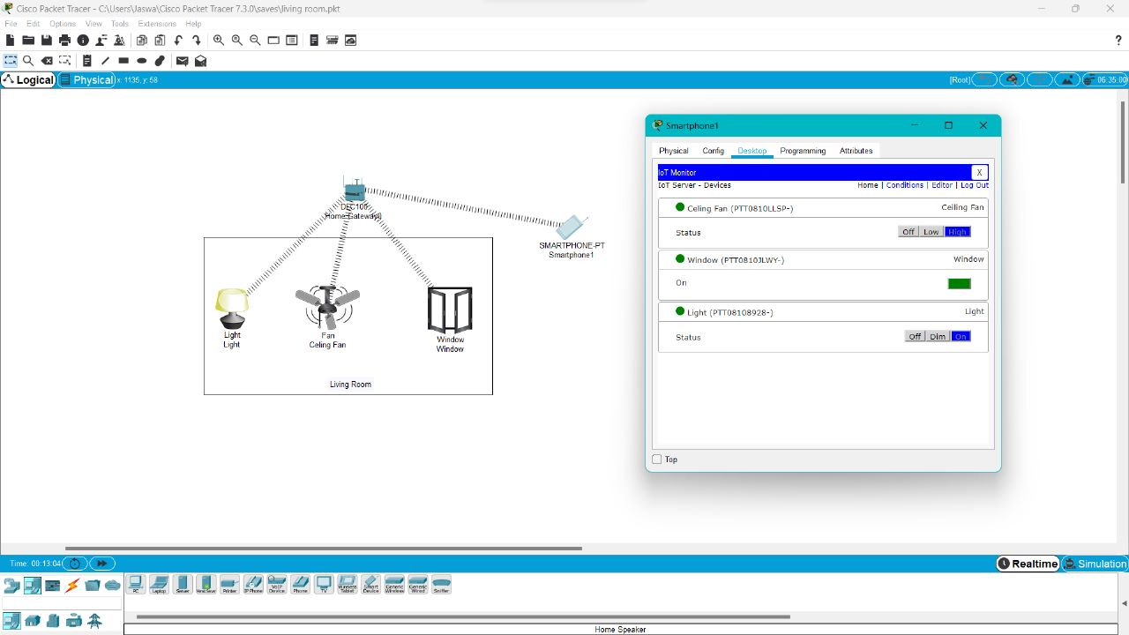

30. Smart Garden in Cisco Packet Tracer 192211123

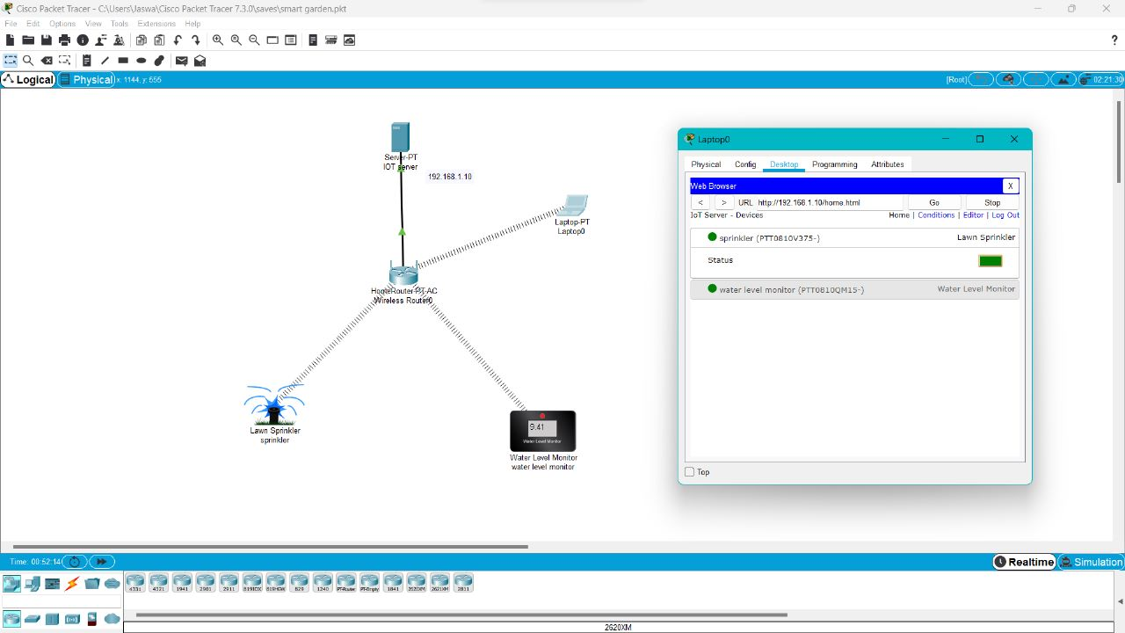

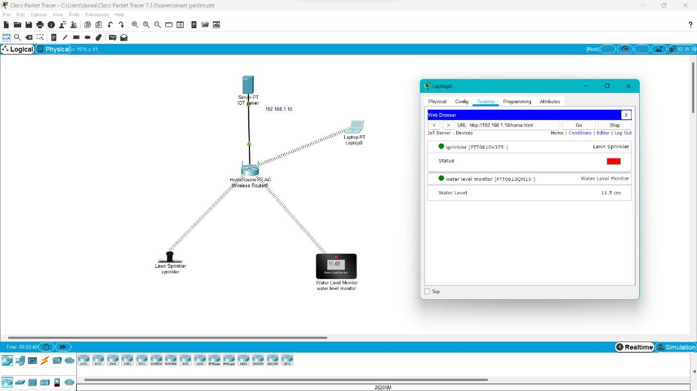

31. IOT Devices in Networking Using Cisco Packet Tracer 192211123

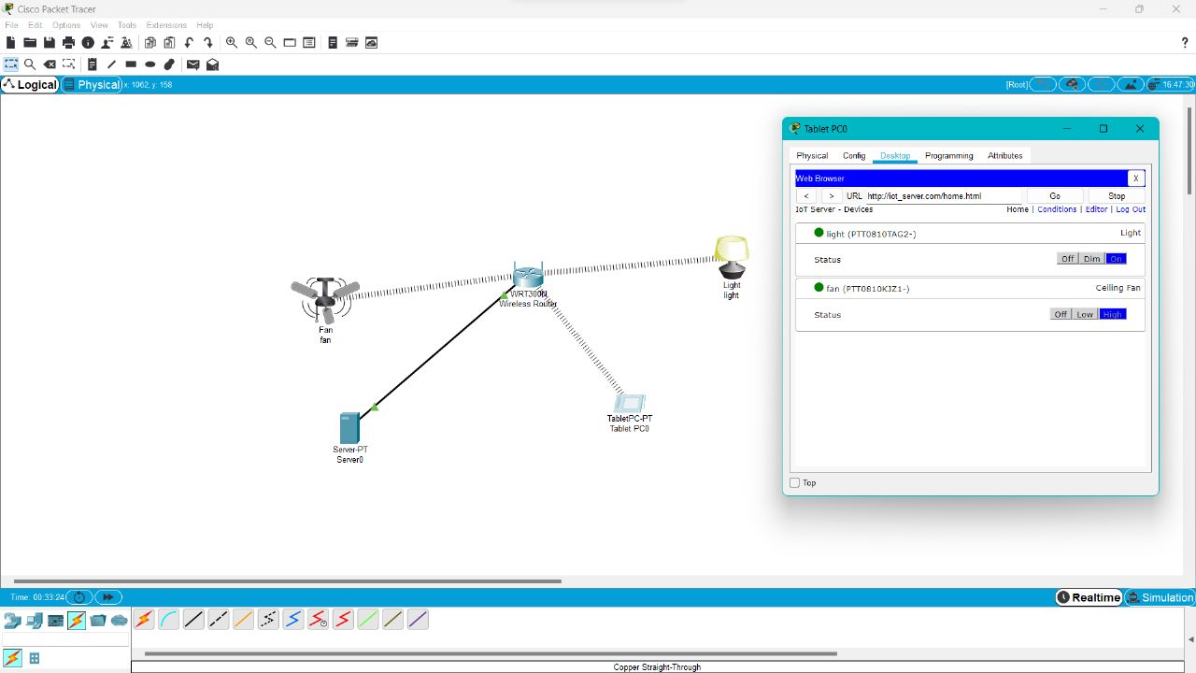

32. Control of Fan, Light, Window & Application of Using Cisco Packet Tracer 192211123

